FUNDACJA BEZPIECZENSTWO DLA PACJENTÖW

PATIENTS SAFETY FOUNDATION
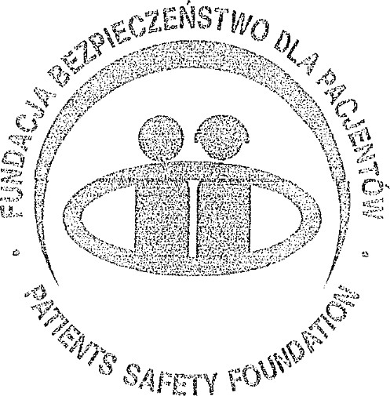
Fundacja bezpjeczeåstwo dla Pacjent6w 9+123L6dt, ul. Oszczepowa 57
NIP 7272689858 Regon 100279128 tel. kom +48604518474
Minister for Foreign Affairs
Department of Foreign Affairs
Government of Ireland
Dear Minister,
As President of the Patient Safety Foundation in Poland, I wish to express our strong support for the submission made by the Irish Patients Association (IPA) on priorities for Ireland's EU Council Presidency in the second half of 2026, with a particular focus on the formal adoption of a European Charter of Patients' rights.
The Patient Safety Foundation is a national non-governmental organisation established in 2006 to promote safety in healthcare and to involve patients as partners in their own treatment. We work closely with the Ministry of Health, WHO patient safety initiatives, and other patient organisations to improve the quality and safety of care in Poland. Our daily work shows that patient safety, dignity, and informed participation are not abstract concepts; they are conditions for trust in health systems and for better outcomes.
The principles contained in the European Charter of Patients' Rights, including access to care, information and informed consent, privacy, dignity, safety, and effective redress, are directly linked to patient safety. When these rights are not clearly defined, consistently implemented, and transparently monitored, preventable harm and avoidable suffering increase.
When they are respected, patients are safer, health professionals are better supported, and systems become more resilient.
From a Polish perspective, we have seen how progress in national patient rights legislation and patient safety policy can be accelerated when there is a clear reference framework. However, we also see persistent differences in how patients' rights are understood and applied, both within our country and across Europe. This fragmentation undermines equity and complicates cross-border care. A harmonised European Charter of Patients' Rights would provide a common standard that can guide legislation, practice, and evaluation in all EU
States.
We therefore welcome IPA's proposal that Ireland's Presidency should build on the momentum created by the Call for Harmonisation of Patients' Rights launched in Katowice on 13 March 2025 and move towards formal EU-leveI adoption of a modernised Charter. This would complete the "rights pillar" of the European Health Union and give patients a clear, accessible statement of what they can expect wherever they receive care in the European Union.
We also support the emphasis in the submission on updating the Charter so that it is coherent with the current EU framework on fundamental rights, data protection, artificial intelligence, and health data governance. As health systems become more digital and data-driven, patients need explicit assurances that their rights to safety, information, consent, and redress are protected in these new contexts. A modernised Charter, aligned with this framework, would help future-proof patient rights and create a more predictable ethical environment for innovation.
On this basis, the Patient Safety Foundation, Poland, fully endorses the Irish Patients Association's submission to the Department of Foreign Affairs. We encourage Ireland, during its EU Council Presidency, to prioritise the development and adoption of a European Charter of Patients' Rights and to ensure that patient safety and patient involvement remain central throughout this process.
Regards
Jolanta Bilihska, President
Patien+afety oun#mtjpn, Poland
ilifiska

